## Extending SharePoint 2010 Search

**Lab Time**: 60 minutes

**Lab Folder**: C:\Student\Labs\Search

**Lab Overview:** SharePoint 2010 offers several new ways to customize and extend enterprise search capabilities. In the first exercise, you will create a search application for finding and managing tasks. Then in the next exercise, you will learn to create a new content source and exclude certain information from the crawl.

Lab Setup Requirements

* Before you begin this lab, you must run the batch file named **SetupLab.bat**. This batch file creates a new blank site collection at the location **http://intranet.wingtip.com/sites/SearchLab**.

### Exercise 1: Customizing Search Center

In this exercise, you will customize the Search Center to create the foundation for a search-based application. You will create a task list as a data source and then add a scope for the list. Finally, you will create a Search Center with custom settings to search the new scope.

**IMPORTANT**: Before you begin these steps, make sure that you have the Standard, Enterprise, and Publishing features activated at both the Site Collection and Site levels.

1. If you haven’t already done so, run the batch file named **SetupLab.bat**, found in the folder for tis lab to create the new site collection that will be used to test and debug the code you will be writing in this lab. This batch file creates a new site collection at an URL of **http://intranet.wingtip.com/sites/SearchLab**. Launch Internet Explorer and browse to this site
2. Verify that you have the **Standard, Enterprise, and Publishing** features activated at both the **Site Collection** and **Site levels:**
3. Select **Site Actions » Site Settings » Site Collection Features** (in the Site Collection Administration section).
   1. Verify that the three Features are active or activate them if necessary.
   2. Use the breadcrumbs to navigate back to Site Settings.
4. Select Site Actions » Manage Site Features.
   1. Verify that the three features are active or activate them if necessary.
5. Now you need to create a new task list to hold some sample data we’ll index:
   1. Select Site Actions » View All Site Content.
   2. Click Create and create a new Tasks list for the site named Project Tasks.
   3. Using the picture below, add these tasks to the list. Make sure to use the High/Normal/Low priority settings on these tasks.

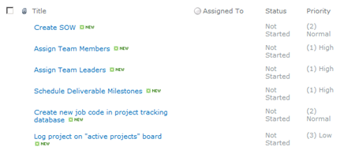

1. Now you need to create a **Search Center** sub site, but before doing that, you need to verify the necessary features are active.
2. Select **Site Actions » Site Settings**.
3. Pick **Site Collection Administration » Site collection features**.
4. Verify the following features are active. If they aren’t, activate them:
5. Office SharePoint Server Enterprise Site Collection features
6. Office SharePoint Server Publishing Infrastructure
7. Office SharePoint Server Standard Site Collection features
8. Verify the similar corresponding three (3) features are active at the site level (**Site Actions » Site Settings » Manage site features** under the **Site Actions** section).
9. Next, we need to create a new **Search Center** sub site in the **SearchLab** site. Select Site Actions » New Site. Use the following information to create the subsite:
   1. **Title**: Search Center
   2. URL: searchcenter
   3. Template: Search » Enterprise Search Center
10. With the **Search Center** site created the next step is to modify the publishing pages within the Search Center. First create a new page that will search for important tasks:
    1. Browse to http://intranet.wingtip.com/sites/SearchLab/searchcenter. On the new search site, click Site Actions » View All Site Content.
    2. Select the Pages library.
    3. In the Pages library, click Documents » New Document » Page.
    4. Select to create a new (Welcome Page) Search Box and use the following to create the page:
    5. **Title**: Important Tasks
    6. **URL Name**: ImportantTasks.aspx

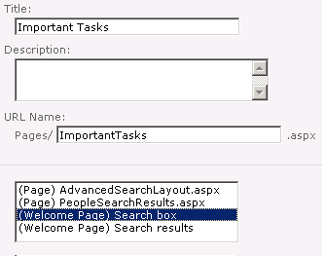

Next create the search results page for important tasks:

1. In the Pages library, click Documents » New Document » Page. Select to create a new (Welcome Page) Search Results and use the following to create the page:
   1. **Title**: Important Tasks
   2. **URL Name**: ImportantTasksResults.aspx

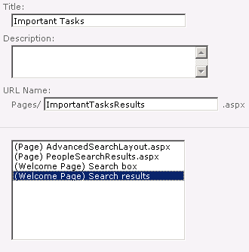

1. Now you need to add a new tab to the **http://intranet.wingtip.com/sites/SearchLab/searchcenter** homepage.
   1. On the new search site, click Site Actions » View All Site Content.
   2. Click the Tabs in Search Pages library.

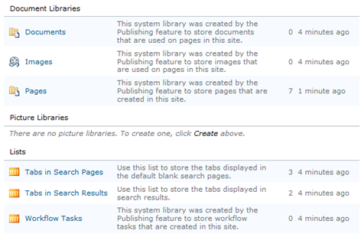

* 1. Select Items » New Item from the ribbon and create a new tab with a **Tab Name** of Important Tasks and a **Page**: file name of ImportantTasks.aspx

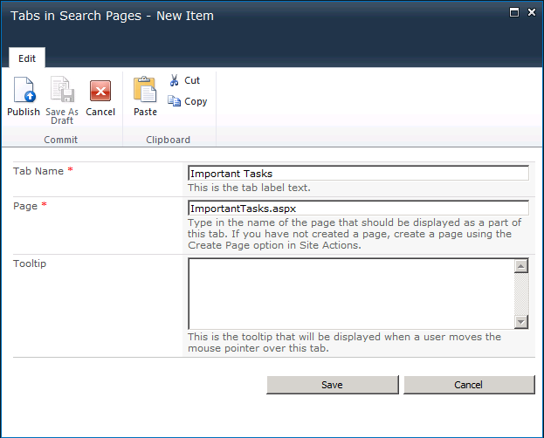

* 1. Click the **Save** button.

1. With the new tab created, you now need to configure that tab to send users who execute searches on it to the custom results page.
2. Browse to http://intranet.wingtip.com/sites/SearchLab/searchcenter.
3. Click the Important Tasks tab to jump to the ImportantTasks.aspx page.
4. Using the ribbon select Page » Edit.
5. In the Web Part that contains the search box, click the Web Part Menu drop down arrow in the right upper corner of the web part and pick Modify this Web Part.
6. In the Search Box task pane, expand the Miscellaneous section. Change the Target search results page URL from results.aspx to ImportantTasksResults.aspx and click OK at the bottom of the task pane.



1. Now check the page in to save your changes. You can find the **Check in** button on the **Page** tab.

Now that the new Search Center is created, you will create a search scope to use with it. The search scope will include only the task list you created earlier.

1. Open the **SharePoint 2010 Central Administration** site.
2. Click **Application Management » Manage Service Applications**.
3. On the **Manage Service Applications** page, click the **Search Service Application** link. This brings you to the **Search Administration** page.
4. Click the **Scopes** link in the **Quick Launch** bar under the **Queries and Results** section.
5. On the **View Scopes** page, click **New Scope**.
6. On the **Create Scope** page, enter **Important Tasks** in the **Title** field.
7. Enter ImportantTasksResults.aspx for the **Target Results Page** and click the **OK** button.

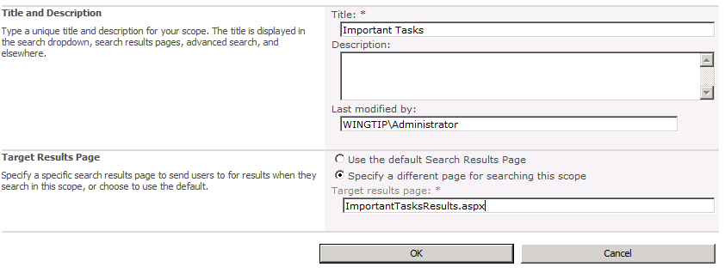

1. When the new scope is created, click the **Add Rules** link in the **Upgrade Status** column to add a rule to the scope. We will filter the results to include only those from our list we created previously.
2. Leave the **Web Address** option selected and enter the complete URL to the task list (e.g. **http://intranet.wingtip.com/sites/SearchLab/Lists/Project%20Tasks**) in the **Folder** field in the **Web Address** section.
3. Click the **OK** button.
4. With the scope created you now need to start a full crawl.
   1. Click the Content Sources link in the Quick Launch under the Crawling section.
   2. Select the Local SharePoint sites and then Start Full Crawl to trigger the search indexer to index all the content in our new task list.

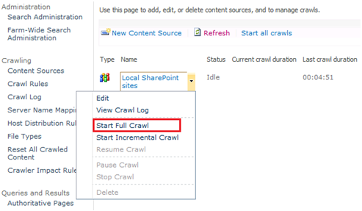

* 1. Wait for the full crawl to finish (about 5 minutes).

1. Finally, you need to update the scope. This will happen automatically but not for quite a while. Let’s force it to update the scope now:
2. Select Search Administration from the top of the Quick Launch.
3. In the System Status section, you’ll see that the 2nd to last item reports one scope is pending update. Click the Start update now link to initiate it.

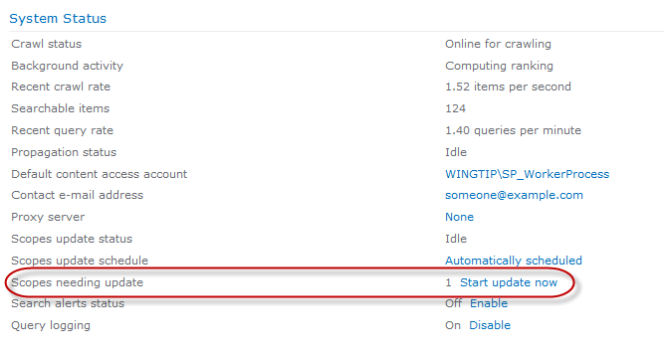

Once the new scope is ready, you must return to the **Search Center** and edit the web parts so that they will use the new scope.

1. Return to the Search Center (**http://intranet.wingtip.com/sites/SearchLab/searchcenter**) and click the **Important Tasks** tab. This will take you to the ImportantTasks.aspx page.
2. Enter a term and perform a search. This will take you to the ImportantTasksResults.aspx page.
3. Select **Site Actions » Edit Page** to place the page in edit mode.
4. In the Web Part that contains the search box, click the arrow in the right upper corner of the Web Part and pick Edit Web Part.
5. In the Search Box task pane, expand the **Miscellaneous** section. Change the **Target search results page URL** from results.aspx to ImportantTasksResults.aspx and click **OK** at the bottom of the task pane.
6. On the **Search Core Results Web Part**, select Edit Web Part from the Edit menu (in the right upper corner of the web part).

**Note**: Once you select the edit option you may need to scroll the web page up to the top to see the Search Core Results edit options.

1. Under the **Location Properties** section, select **Local Search Results** in the **Location** property and enter **Important Tasks** in the **Scope** property.

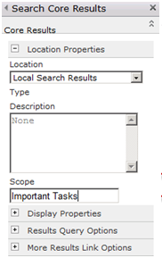

1. Click the **OK** button.
2. **Check In** the page.
3. You should now be able to return results from the task list you created earlier.

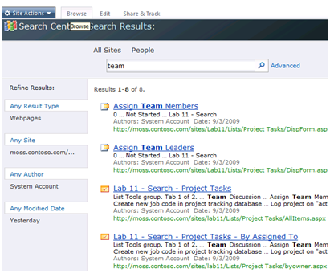

In this exercise you created a new Search Center site and customized it to use a new search results page that leverages a custom scope you created.

### Exercise 2: Creating a new Content Source to Exclude Content

In this exercise, you will create a new content source and exclude certain proprietary content from being indexed.

1. Open **SharePoint 2010** **Central Administration**
2. Click **Application Management » Manage Service Applications**.
3. Scroll down to the middle of the **Manage Service Applications** page and locate the **Search Service Application** entry. In the **Type** column in the middle of the page, click on the **Search Service Application**.

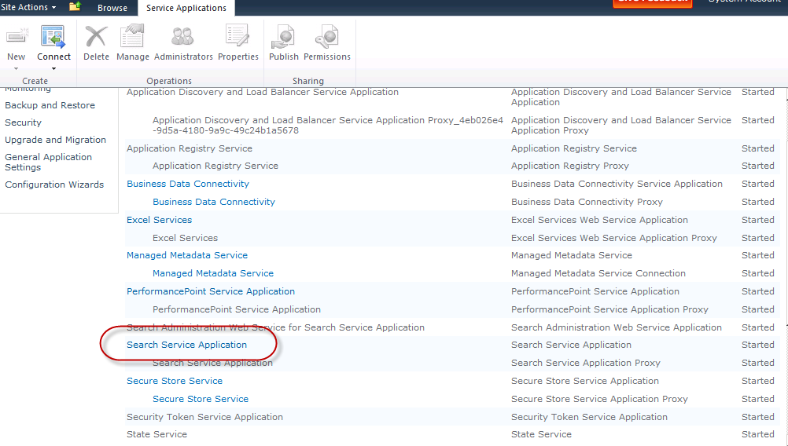

1. With the Search Service Application entry highlighted, click the **Properties** button in the ribbon toward the top of the page. Notice the properties that have already been configured for this service application. When you are done reviewing, close the Properties window.

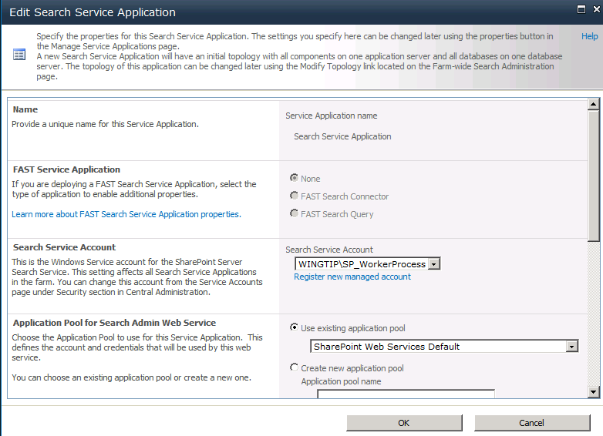

1. Click on the **Manage** button in the ribbon at the top of the page.
2. Notice all the options you have to administer Search in SharePoint

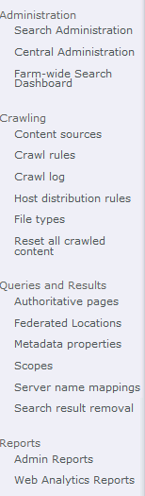

1. On the left hand side of the **Search Service Application** page, click on the **Content Sources** link beneath the **Crawling** header.

Mouse over the **Local Microsoft Search Server sites** entry and a down arrow should appear revealing a set of options. Click the **Edit** option from the drop-down menu which will open the **Edit Content Source** page for the specific content source.

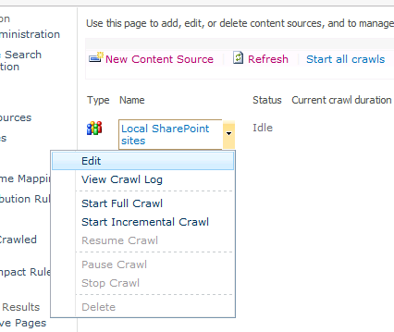

1. Scroll down to the middle of the page to the **Start Addresses** section.

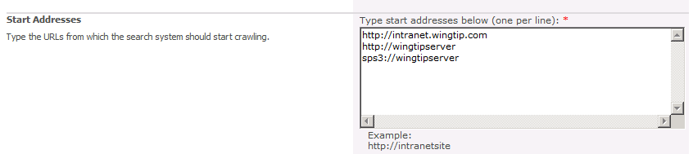

1. Clear out (delete) the **http://intranet.wingtip.com** entry from the list. Leave all other settings the same and click the **OK** button at the bottom of the page.

You will now create a new content source for the Wingtip intranet and exclude certain content.

1. Click the **New Content Source** button at the top of the page.
2. Use the following settings

**Name:** Intranet

**Content Source Type:** SharePoint Sites

**Start addresses:** http://intranet.wingtip.com

**Start full crawl of this content source:** checked

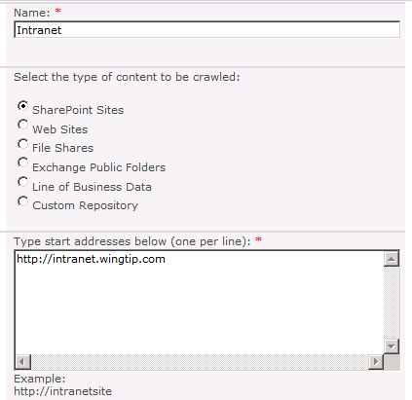

1. Leave other settings as default and click **OK**. Notice that the Intranet content source is added to the list and the crawl has been initiated as seen by the Starting entry in the Status column. **Refresh the page** and you'll see that the entry is **Crawling Full**. Once it nears completion, the entry will change to **Completing**, and then to **Idle**, once it has completed.

**Note**: The full crawl will take 3-5 minutes to complete. Refresh the page to see the status.

1. Hover over the **Intranet** content source entry and select **View Crawl Log** from the drop-down list. A page appears that shows status of contents that have been crawled.

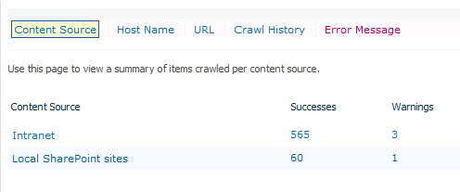

You will now create a new **Crawl Rule**.

1. On the left-hand side of the page, click the **Crawl rules** hyperlink. This will take you to the **Manage Crawl Rules** page.
2. Type the following URL inside the textbox at the top of the page: **http://intranet.wingtip.com/sales**, then click the **Test** button.

**Note:** This site does not exist… don’t worry about that for now.

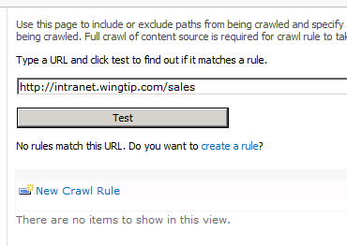

You will notice that no rules currently exist.

1. Below the **Test** button, click on the **Create a rule** hyperlink. This will take you to the Add Crawl Rule Web page and pre-populate the Path with the appropriate URL. Click on **OK**.

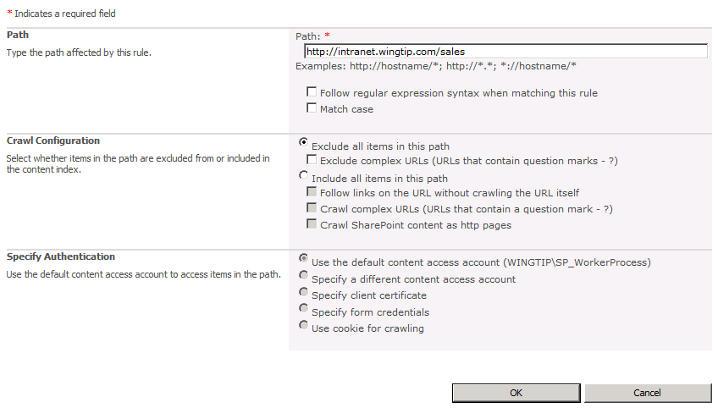

1. On the left-hand menu, click on **Content Sources**. Hover over **Intranet** and from the drop-down menu, click on **Start Full Crawl**.
2. Wait for the crawl to finish then click on **Crawl Log** in the left-hand menu. You should see that the content source for Intranet should be reduced significantly because you excluded the Sales site content.

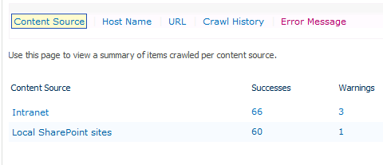

In this exercise you created a custom SharePoint search scope that excluded content from one of the content sources.